New Features

Track Minister Attendance
Now you can mark whether a minister was absent for an assignment. We added a check box to the minister's History of Assignments window.
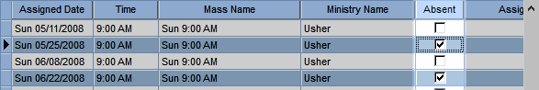
You can run the Minister Absences report under minister listings to see attendance information.

Ministry Away Period
If a minister serves in multiple ministries, you can set their away period for a particular one.
For example, a minister may not want to serve as a lector the week of Christmas, but is still available to serve in the choir.
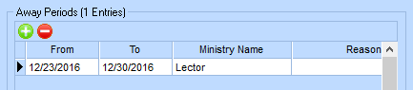

Delete a Scheduled Position
If you need to remove a position that has already been scheduled, you can now right-click it and delete it from the schedule.
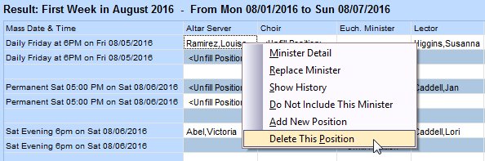

Find Out What's New
Do you read release notes? (Well, you're reading them right now!) We made it easier to get to them from within Ministry Scheduler.
When there are new release notes, you'll see the yellow bell icon at the top-right. Once you click the bell and see the release notes, it changes back to white.
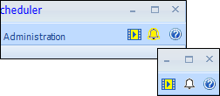

Online Data Security Update
After June 1, 2017, we will disable TLS 1.0 and upgrade to TLS 1.2. This affects all of our public APIs and online payment transactions. If you use those, you must update your operating systems and browsers and inform your congregants to upgrade as well.
For more information on what this means for you, see our official notice for the Security Update for Our API Consumers.

Post for Ministers to Serve Anytime
Now, you can quickly select the Serve anytime option on multiple ministers' Type & Time Availability window for a particular mass type.
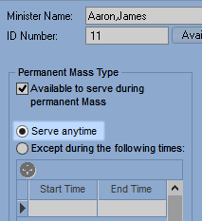
In the Cannot Serve Time of Day quick posting, select Serve anytime and complete the process as usual.
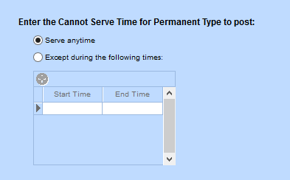
We also added an option to select the Serve Mass Type check box if it isn't already selected for that mass type on the minister's record. We recommend doing this if you want to apply your changes for the next schedule you run.
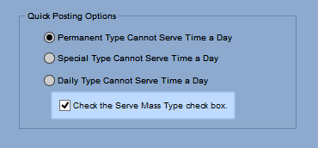
If you don't select this, the Serve anytime or Except times you enter will display on the minister's record but are not considered during scheduling (like Permanent Mass Type in the image below).
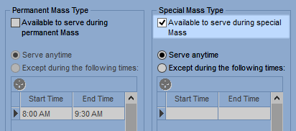

Improved Features

Serve With List Validation
Previously, if ministers were set to serve with each other but had different preferences (like serve days, class/group, ministry, and so on), they were never scheduled together. Now you'll be notified if ministers have differences when you add them to Serve With lists.

Redesigned Grids and Buttons
We improved the look of grids and grid buttons. Instead of the words Insert or Line Delete, we used the icons you're familiar with for adding and deleting , and a new icon to represent reordering .
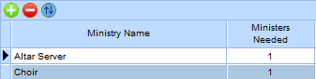

Find All Your Processes in One Place
Have you ever been looking for a quick posting or process but couldn't remember where it was? Now, you don't have to worry! We created shortcuts for all your quick postings and processes under a Processes tab.
You can still find each one under its original section, too.

Collapsible Access and Privileges
If you've set up access and privileges, you know how hard it can be to scroll through all the program areas. We redesigned the grid so you can easily see the windows in the program level you want. You can expand and collapse the rows for better viewing.
We also added a handy Find button, so you can search for a specific window or process.
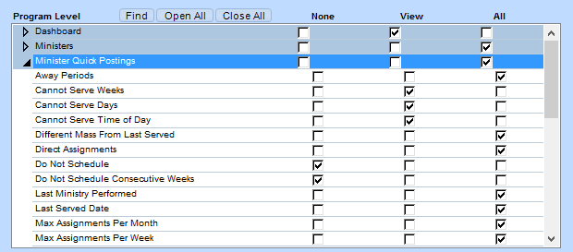

Activate/Inactivate Minister Messages
We improved the messages in the Activate/Inactivate Ministers process so they better pertain to your data. This way, you don't waste time on messages you don't need to see.

New and Improved Reports

Search for a Particular Report
In the report list, you can now find a report you're looking for without expanding all the groups.

Page Breaks for Printed Schedules
You can now print schedules with or without page breaks. We added a check box for all schedule reports. To remove page breaks and save paper, clear the check box.
