New Features

Customize Your Program Name
You can change the name that displays at the top of your program. This is helpful for distinguishing between multiple copies of the program for your parish, school, campus, and so on. For more information, see Customize the Program.

Custom View of Transactions for Vendor Invoice
When creating a vendor invoice, you can now customize the Transaction History listing.
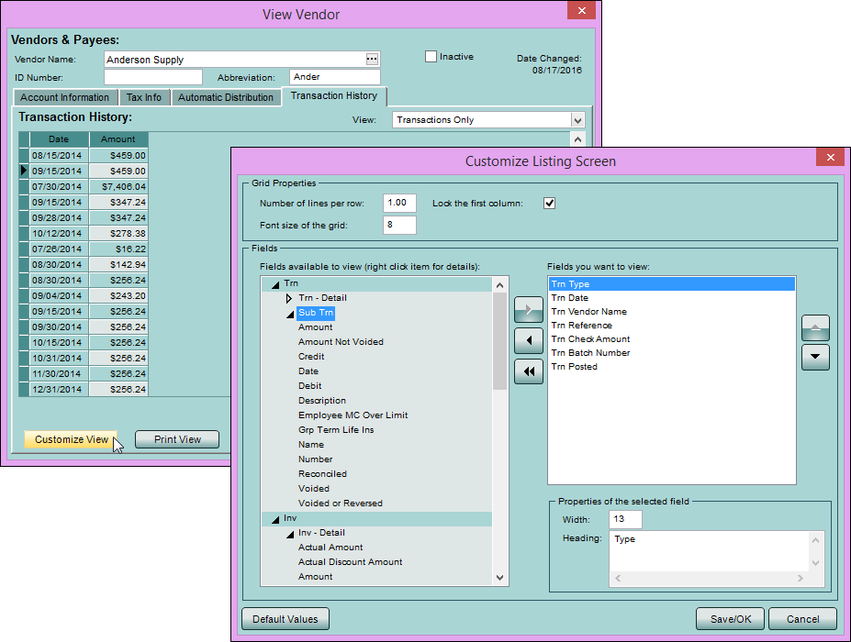

Change Address Abbreviations
We added a process you can use to:
- abbreviate addresses – for example, "236 West Lincoln Street" is changed to "236 W Lincoln St".
- remove abbreviations – for example, "499 N Central Ave" is changed to "499 North Central Avenue".
- change the case of addresses – for example, change "236 Myrtle Dr" is changed to "236 MYRTLE DR".
For more information, see Change the Format of Addresses.

Find Out What's New
Do you read release notes? (Well, you're reading them right now!) We made it easier to get to them from within Ledger/Payroll.
When there are new release notes, you'll see the yellow bell icon at the top-right. Once you click the bell and see the release notes, it changes back to white.
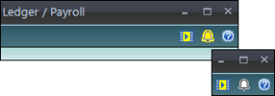

Improved Features

Redesigned Grids and Buttons
We improved the look of grids and grid buttons. Instead of the words Insert or Line Delete, we used the icons you're familiar with for adding and deleting , and a new icon to represent reordering .
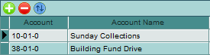

Collapsible Access and Privileges
If you've set up access and privileges, you know how hard it can be to scroll through all the program areas. We redesigned the grid so you can easily see the windows in the program level you want. You can expand and collapse the rows for better viewing.
We also added a handy Find button, so you can search for a specific window or process.
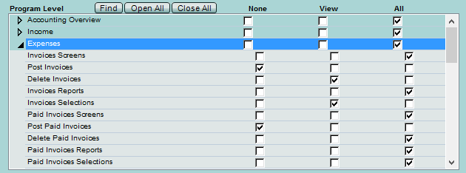

Full Dates on Journal Entries
Journal entries now use the full date (mm/dd/yyyy) instead of just the month and year. This includes adjusting and recurring journal entries, money transfers, and depreciations.
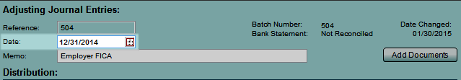

Transaction Listing Data Range
You can now filter transaction lists using a date range. This gives you more control over which transactions you see.
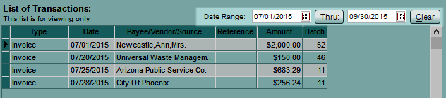
We removed the date range from the quick filter since you now control that directly on the listing.
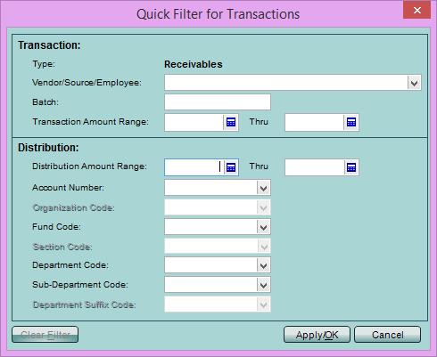

Bank Reconciliation with a Future Date
Before you run your bank reconciliation, a warning now displays if you enter a future date. That way, you won't clear the wrong transactions.

Enhanced Vendor Search
You can now search for a vendor record by their business name or individual name.

Better Account Number Search
When looking up an account number, you no longer have to enter dashes or other separators. Just enter the number, and the separators are filled in for you!

Log Changes to Employee Filing Status
Changes made to an employee's filing status are now recorded in the User Log.

Log Name Changes
Changes to names for vendors, income sources, and employees are now recorded in the User Log.

Lock Down Reconciled Transactions
On the Initial Setup window, we added a way to lock down reconciled transactions.
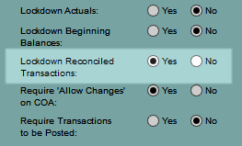
- If you select Yes, a warning displays if you try to change any distribution line associated with a cash account that has been reconciled. If changes are made after acknowledging the warning, they are recorded in the log.

View PYFB, RE, and Net on the Trial Balance
On the Trial Balance report, you can choose to show the Prior Year Fund Balance, Retained Earnings, and Net Activity. This is helpful if you have transactions posted in those accounts and need to see them.
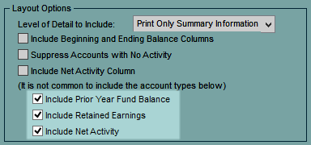
Normally these are hidden since the income and expense accounts feed the Net, which feeds the RE, which feeds the PYFB. Selecting these may cause your figures to be off.

Last Year Cash Flow Comparison
On the Cash Flow statement, we added an option to compare this year's totals with last year.
On the Cash Flow statement, click Set Options then Set Categories, and select Include a comparison with last year. Or on the Statement of Cash Flow report, select the option in the Additional Layout window.
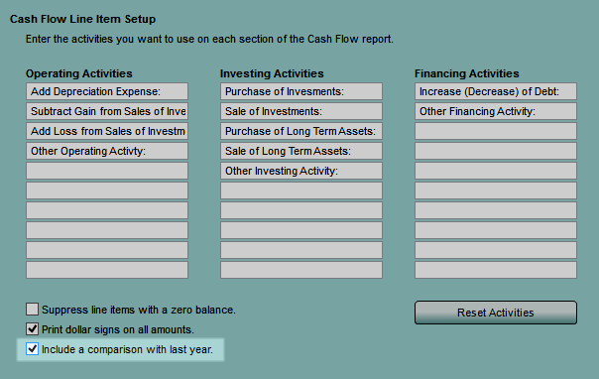

Income Statement Last Month and Variance
We added two new column options for the Income Statement: Last Month and Variance - Current Month Minus Last Month.
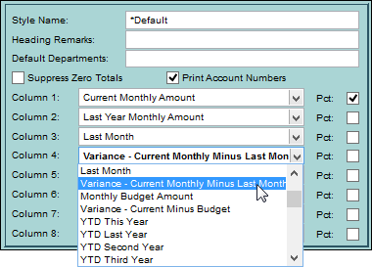
You can include these on your statement by editing the style layout.

'Doing Business As' Name
We added an option to print "DBA" before the vendor name on the 1099.
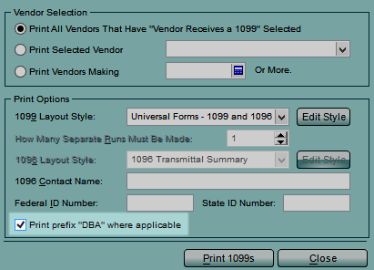
If you select this, any variation you've used in your vendor records ("Dba", "dba", "d.b.a.", etc) is printed as "DBA" to comply with the universal form allowance.
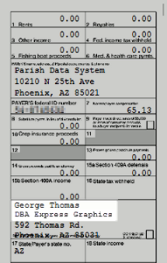

Vendor 1099
Now, on the vendor 1099, you can select which box to print totals in. For the vendor account on your COA, select which amount prints in the 1099 box. If you don't select anything, totals are accrued to the non-employee compensation box by default.
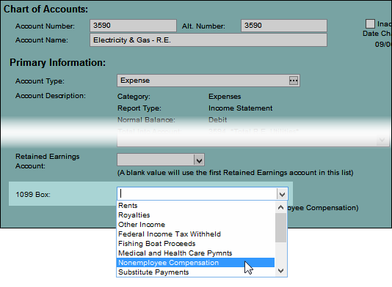
If needed, you can enter the breakdown of totals in the Alter Totals window.
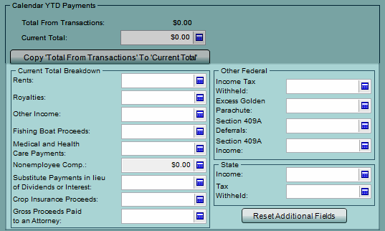
Box 5 on the 1096 now includes the 1099 totals from boxes 1, 2, 3, 5, 6, 7, 8, 10, 13, and 14.

New Affordable Care Act Codes
We added the new ACA codes (1J and 1K) as options in the Employee Wage setup window and in the ACA setup process.

Updated Tax Forms
We updated the universal forms (W-2, W-3, 944, 1096, and 1099) for the 2016 tax year.
We also updated the electronic W-2. For more on these changes, see our blog article on IRS Filing Changes.

Print in Invoice Order
We added a print order option. Now, you can print checks in the same order as the invoices were entered. This way, you can easily match the checks to the invoices.
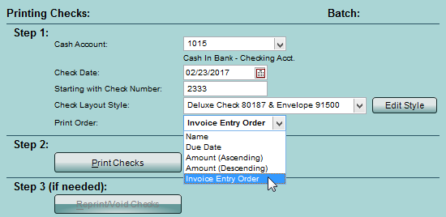

Accounting Report Options
Sometimes you can't see the forest for the trees. We made it easier to see the big picture on your accounting reports.
On the Income Statement and Balance Sheet, we added an option to drop the cents and show whole dollars amounts.
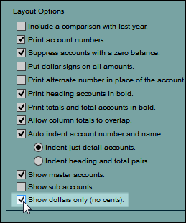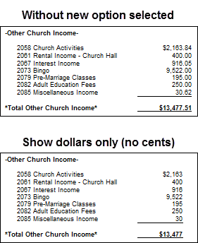

Note
This option does not round to the nearest whole number. For example, $50.99 + $50.99 will show as $50 + $50, and the total $101.98 will show = $101.
On the Income Statement, you can also select the number of decimal places to display for percentages.
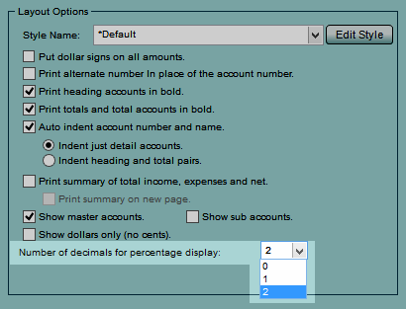

Export and Import Existing Values
In the Budget Planning WS (Spreadsheet Export), you can now include current amounts entered in PDS.
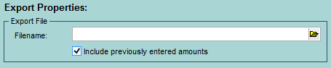
In the Budget Planning WS (Spreadsheet Import), if amounts are blank in your spreadsheet, you can overwrite previously entered amounts in PDS.
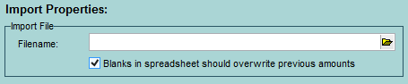

New and Improved Reports

Search for a Particular Report
In the report list, you can now find a report you're looking for without expanding all the groups.

Compare Income Statement Data
Previously, the Statement of Activity only went back 2 years. Now, you can compare up to 5 years of data.

General Ledger Ordered by Date
You can now view the General Ledger report with transactions grouped by date.
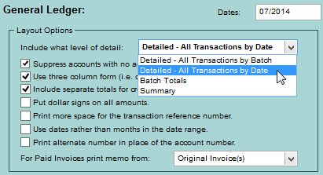

Separate First Name and Middle Initial
In reports and listings, you can now separate the first name and middle initial. This is helpful in ACA reporting since the first name and middle initial must be separate.
When you choose fields for a report or customize the fields in a listing window, you can select First Name, First Name Raw, and Middle Initial.
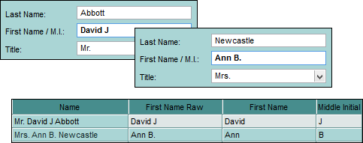
This applies to employees, ACA covered individuals (dependents), and vendors in reports, listings, Electronic W-2 Export, Nelco E-File, Non-Universal W-2, and ESS upload.

Customize the Cash Flow Statement
You now have more control over the Statement of Cash Flow. You can define subcategories for each activity.
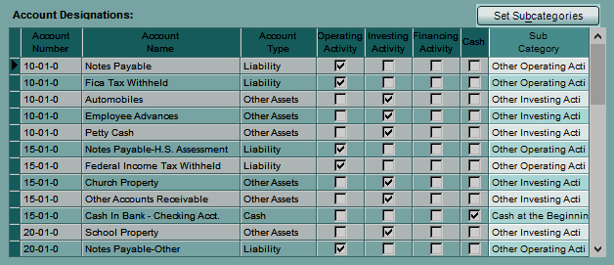
You can rename these as you want them to display on the statement.
